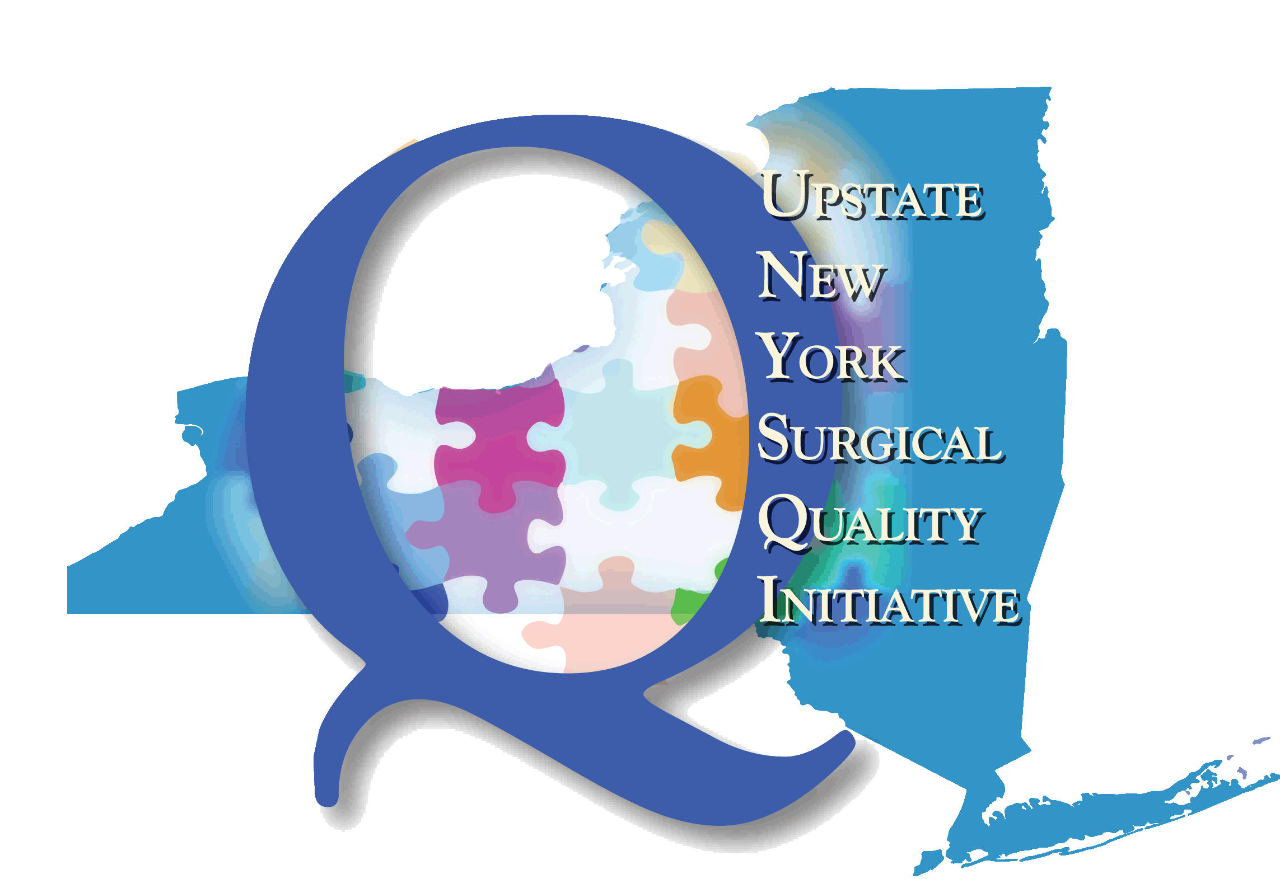

**Upstate New York Surgical Quality Initiative (UNYSQI)**

**Background:**

* Launched in early 2008
* UNYSQI brings the partnership between Excellus Health Plan and the American College of Surgeons’ (ACS) National Surgical Quality Improvement Project (NSQIP) to collaborating network providers.
* ACS NSQIP is the first nationally validated, risk adjusted, outcomes-based program to measure and improve the quality of surgical care.

**Goal:**

This Health Plan sponsored, team-learning collaborative provides for sharing of best practices and expertise to help drive statewide quality improvement in surgical care, through use of the ACS NSQIP – the “Gold Standard” for surgical results reporting.

The UNYSQI strives to improve the quality of care for the surgical patient through data driven, focused, and measurable efforts utilizing proven best practices that are tied to financial results. Complications can raise the median cost of hospitalization for major surgical procedures by up to five-fold[1]. The UNYSQI works on the premise that system problems should be solved through outcome measurements and real time data. An analysis of every surgical error and complication must be performed to prevent reoccurrence; resulting in reduced harm, improved patient outcomes, reduced inpatient length of stay, and reduced readmissions. As responsibility for these costs shifts to the provider, whether at a rural hospital or an academic medical center, the savings realized can be the difference between profitability and loss.

**Benefits of Joining UNYSQI:**

Participating hospitals have the benefit of using the data from NSQIP to reduce post–op mortality rates, reduce post–op morbidity rates, reduce the median length of inpatient stay, and to meet CMS Surgical Care Improvement Program (SCIP) reporting requirements.

Payment changes instituted by CMS and private health care payors makes a direct business case for investment in quality programs that improve outcomes. Revenue is lost daily as payors curtail reimbursement based on outcomes. The financial benefits of ACS NSQIP far exceed the annual cost and dedicated resources. As CMS and other payors increase focus on quality outcomes, ACS NSQIP is especially relevant to addressing quality and efficiency issues.

**The clear and compelling business case for creating ACS NSQIP sustainable value is through:**

* Reliable clinical data obtained from the patient’s chart (not insurance claim data) to direct tactical and strategic decision making
* Risk-adjusted, accounting for the health of the patient and factors that increase the risk of complications
* Case-mix adjusted, accounting for complexity of operations performed
* Improved hospital profit margins based on higher quality of care
* Following patient for 30 days postop – discovering more complications than other quality programs
* NQF-endorsed outcomes measures developed in partnership with CMS
* Pinpointing error producing failures within a complex system
* Credibility of QI program attracts and retains nurses and surgeons
* Motivating and increasing professional satisfaction & cooperation
* Promoting efficiency in the use of hospital resources
* Increasing opportunities to receive hospital performance incentive plan (HPIP) P4P (pay for performance) incentives through participation: As a risk adjusted model, the ACS NSQIP can help counter any perceived disincentive for surgeons to treat complicated patients
* Valid national benchmarking
* Enhancing hospital reputation
* Providing best practice solutions

**Current Hospital Participants:**

**Western New York**

* Kaleida Health (2 sites)
* Erie County Medical Center
* United Memorial Medical Center

**Finger Lakes Region**

* Rochester General Hospital
* Strong Memorial Hospital
* Clifton Springs Hospital & Clinic
* Highland Hospital
* Newark-Wayne Community Hospital
* Unity Hospital

**Central New York**

* Cayuga Medical Center
* St. Joseph’s Health Hospital
* SUNY Upstate Medical University Hospital (2 sites)

**Utica/Rome/North Country**

* A.O. Fox Hospital
* Bassett Medical Center
* Samaritan Medical Center

**www.UNYSQI.org**

**For more information or to join this evidence-based collaborative, please contact:**

**Denise Hull, Consultant, PPI (585) 993-1008**

[UNYSQI.Communication@excellus.com](mailto:UNYSQI.Communication@excellus.com)

**Physician Contact:**

**Fergal Fleming, MD, Lead Surgeon Champion (585) 275-1884**

**Fergal_Fleming@URMC.Rochester.edu**

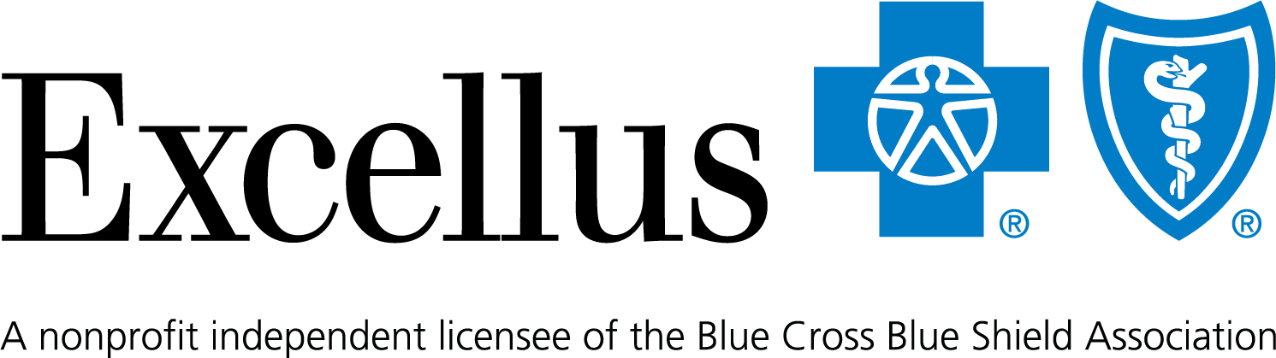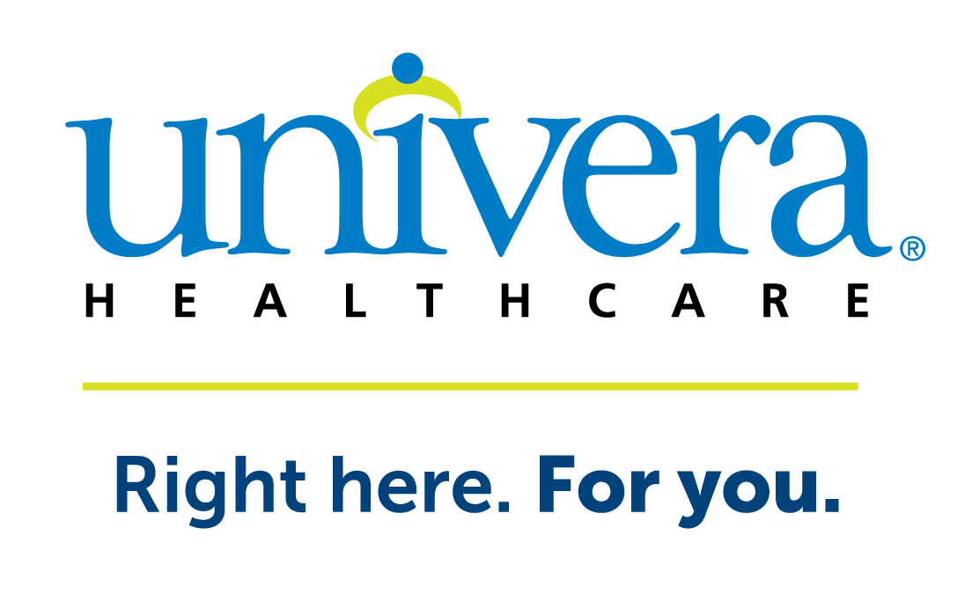

References

1. Rowell, KS, et al. “Use of National Surgical Quality Improvement Program Data as a Catalyst for Quality Improvement.” Journal of the American College of Surgeons. 204 (6): 1293-1300; June 2007.